**Exercise 3**

Data requirements of the movie industry are captured. Each movie is identified by title and year of release. Each movie has length in minutes and is classified under one genre (like action, horror etc.). Each movie has a plot outline. Production companies are identified by name and each has an address. A production company produces one or more movies. Actors are identified by id. Other details like name and date of birth of actors are also stored. Each actor acts in one or more movies. Each actor has a role in a movie. Directors are identified by id. Other details like name and date of birth of directors are also stored. Each director directs one or more movies. Each movie has one or more actors and one or more directors and is produced by a production company.

Relational schema:

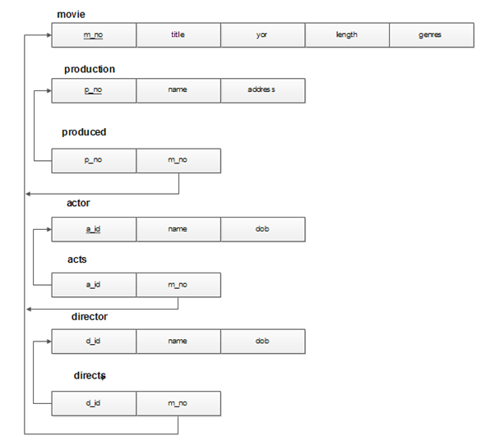

// Creating collections and populating data using MongoDB shell

// Override the _id manually

// Inserting data into 'directors' collection

db.directors.insertMany([

{ _id: 302, name: 'S Krishna', dob: '1983-04-06', movies: [2, 7] },

{ _id: 303, name: 'Santhosh Ananddram', dob: '1986-01-08', movies: [3, 6, 8] },

{ _id: 304, name: 'Tharun Sudhir', dob: '1986-12-28', movies: [4, 6,7] },

{ _id: 305, name: 'Chethan Kumar', dob: '1988-12-07', movies: [5, 6,7] }

]);

// Inserting data into 'movies' collection

db.movies.insertMany([

{ _id: 1, title: 'KGF: Chapter 2', yor: 2022, length: 180, genres: ['action'], directors: [302] },

{ _id: 2, title: 'Pailwaan', yor: 2019, length: 155, genres: ['sports'], directors: [303] },

{ _id: 3, title: 'Yuvarathnaa', yor: 2021, length: 160, genres: ['drama'], directors: [303] },

{ _id: 4, title: 'Roberrt', yor: 2021, length: 145, genres: ['action'], directors: [304] },

{ _id: 5, title: 'James', yor: 2022, length: 150, genres: ['thriller'], directors: [305] },

{ _id: 6, title: 'Horror Movie 1', yor: 2012, length: 120, genres: ['horror'], directors: [302, 304,305] },

{ _id: 7, title: 'Horror Movie 2', yor: 2012, length: 110, genres: ['horror'], directors: [305, 302,304] },

{ _id: 8, title: 'Yash', yor: 2018, length: 156, genres: ['comedy'], directors: [303] }

]);

// Inserting data into 'actors' collection

db.actors.insertMany([

{ _id: 201, name: 'Yash', dob: '1986-01-08', movies: [1, 8] },

{ _id: 202, name: 'Sudeep', dob: '1973-09-02', movies: [1] },

{ _id: 203, name: 'Darshan', dob: '1976-10-16', movies: [2] },

{ _id: 204, name: 'Puneeth Rajkumar', dob: '1975-03-17', movies: [] },

{ _id: 205, name: 'Rakshit Shetty', dob: '1983-06-06', movies: [] }

]);

// Inserting data into 'production_companies' collection

db.production_companies.insertMany([

{ _id: 101, name: 'Hombale Films', address: 'Bangalore', movies: [1, 5,7] },

{ _id: 102, name: 'PRK Productions', address: 'Bangalore', movies: [2] },

{ _id: 103, name: 'Umapathy Films', address: 'Mysore', movies: [3, 4] }

]);

a) List the details of horror movies released in 2012 and directed by more than 2 directors.

db.movies.find({ genres: 'horror', yor: 2012, $expr: { $gt: [{ $size: '$directors' }, 2] } });

b) Same name and title

db.movies.aggregate([

{

$match: {

$or: [

{ yor: { $gt: 2010 } },

{ yor: { $lt: 2000 } }

]

}

},

{

$lookup: {

from: "actors",

localField: "title",

foreignField: "name",

as: "actors"

}

},

{

$unwind: "$actors"

},

{

$match: {

$expr: {

$eq: ["$title", "$actors.name"]

}

}

},

{

$project: {

_id: 0,

actorName: "$actors.name",

movieName: "$title"

}

}

]);

// c) List the details of production companies producing maximum movies (consider the scenario if 2 productions produced the same number of movies).

db.production_companies.aggregate([

{

$lookup: {

from: 'movies',

localField: 'movies',

foreignField: '_id',

as: 'moviesInfo'

}

},

{

$project: {

name: 1,

numberOfMovies: { $size: '$moviesInfo' }

}

},

{

$sort: { numberOfMovies: -1 }

},

{

$limit: 1

}

]);

// List the details of movies where director and actor have the same date of birth

db.movies.aggregate([

{

$lookup: {

from: "directors",

localField: "directors",

foreignField: "_id",

as: "directorsInfo"

}

},

{

$lookup: {

from: "actors",

localField: "actors",

foreignField: "_id",

as: "actorsInfo"

}

},

{

$match: {

$expr: {

$and: [

{ $gt: [{ $size: "$directorsInfo" }, 0] },

{ $gt: [{ $size: "$actorsInfo" }, 0] },

{ $eq: ["$directorsInfo.dob", "$actorsInfo.dob"] }

]

}

}

},

{

$project: {

title: 1,

directors: "$directorsInfo.name",

actors: "$actorsInfo.name"

}

}

]);

//e. Retrieve the names of directors who directed all movies produced by Hombale Films (production company with _id: 101)

db.movies.aggregate([

{

$match: {

directors: {

$all: [302, 304, 306] // director IDs for movies produced by Hombale Films

}

}

},

{

$lookup: {

from: "directors",

localField: "directors",

foreignField: "_id",

as: "directorsInfo"

}

},

{

$project: {

_id: 0,

"Directors of Hombale Films": "$directorsInfo.name"

}

}

])